Subject | Briefing Note: CoSTAR Funding Application
Version | 2.0
FAO | One Surrey Growth Board Members
Date | 11 July 2023
Contact | Daniel Murray, Head of Economy and Growth, Surrey County Council  07787 192 032 / daniel.murray@surreycc.gov.uk

Introduction
This briefing note summarises Surrey County Council’s (SCC) involvement in a successful £51m national CoSTAR (Convergent Screen Technologies and performance in Realtime) Arts and Humanities Research Council (AHRC) funding application.
What is CoSTAR?
The facilities delivered through CoSTAR will deliver the long-term Research, Development, and Innovation (RD&I) infrastructure to establish facilities, resources, and expertise to transform the UK’s screen and performance sector. CoSTAR will support the UK screen and performance sector competitiveness by:
‘…equipping UK firms, assets and institutions with the capabilities, supporting environment and market insight necessary to play a leading role in current and future waves of global media and technology convergence.’
CoSTAR has the following sub-objectives:
- To enable the technological participation of UK firms, assets, and institutions in current and future waves of global media and technology convergence
- To build, strengthen and deepen the UK creative technology ecosystem, maximise arising economic opportunities and support the commercialisation of creative industry technology IP
- To lead and coordinate the technological development of the UK screen and performance sectors
The initial call for proposals (published in October 2022) covered two Lots:
- Lot 1: £51.1m over 6 years, to design, build, develop and test the CoSTAR national lab (and associated facilities and programme) to drive innovation and creativity in the UK’s screen and performance industries.
- Lot 2: £12.6m over 6 years for the delivery of (up to) 3 CoSTAR network labs
The Network Labs will focus on the current challenges faced by industry while the National Lab will support research on future waves of technology.
The application
In February 2023, a CoSTAR national lab grant application was submitted to AHRC by StoryFutures at Royal Holloway, University of London (RHUL) on behalf of a wider bid team. The CoSTAR application focused on establishing a CoSTAR national lab at Pinewood Studios (Iver, Buckinghamshire), and associated facilities and programme to drive innovation and creativity in the UK’s screen and performance industries.

What is SCC’s role?
SCC’s contribution to the bid included a capital commitment of £3m, subject to Cabinet approval, to fund the establishment of a 900 sqm CoSTAR satellite studio and incubator space on the RHUL campus in Surrey. This facility will be used to support the delivery of a CoSTAR programme of incubation and studio facilities, R&D and knowledge exchange and IP/commercialisation support to Surrey-based creative businesses operating from both facilities. It will also provide a gateway to the National Lab and wider CoSTAR networked infrastructure for Surrey businesses.
Who are the other partners involved?
SCC, with Buckinghamshire Council, were core Local Authority civic partners alongside the University of Surrey and University of Abertay (Higher Education Institutes (HEI) partners), National Film and Television School (Training and Production Partner), Pinewood Group Limited (Studio Partner), and BT and Disguise (Tech Partners). Full detail of the CoSTAR partner bid team and roles and responsibilities are set out in Appendix I.
What is the rationale for our involvement?
The diagram below summarises the key drivers behind SCC’s involvement in CoSTAR and the creation of a CoSTAR satellite studio and incubator space on the RHUL campus in Surrey.
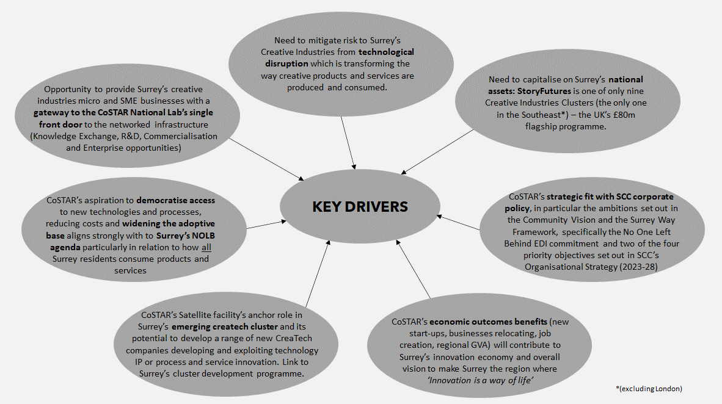
Source: Surrey County Council, 2023

Primary drivers include: the need to build on a locally based national asset (StoryFutures) to ensure Surrey’s creative businesses benefit from CoSTAR’s R&D support and gain access to CoSTAR’s national infrastructure; strong strategic alignment to national and regional policy, in particular Surrey’s Community Vision, Priority Objectives and Economic Growth plan; and CoSTAR’s socio-economic outcomes for Surrey’s creative industries businesses.

What are the benefits of SCC’s involvement?
The main beneficiaries of the CoSTAR Satellite Studio and Incubator space will be Surrey-based creative industry businesses involved in the creation of products, services or experiences that can be enhanced through immersive technologies primarily Augmented and virtual reality (AR & VR)), R&D and commercialisation support.
The CoSTAR Satellite Studio and Incubator Space is projected to deliver significant socio-economic outcomes for Surrey. These include: 250-350 jobs created over 6 years with a 10 year NPV net GVA contribution of c£25-£35m to Surrey’s economy; 200 businesses assisted including 10 new start-ups; 10 relocating businesses and 180 businesses supported through the CoSTAR R&D, Knowledge Exchange, and Commercialisation business support programme.
What are the timescales?
An indicative CoSTAR Satellite Studio and Incubator Space programme plan is set out below. This will be further tested in the coming weeks.
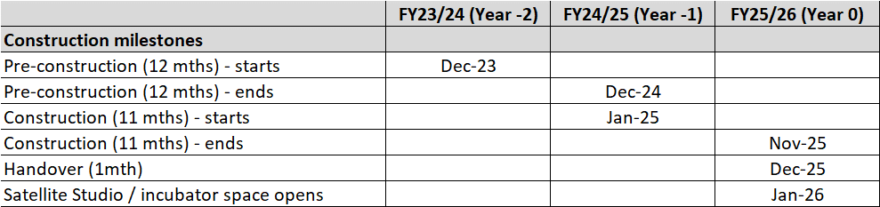
Next Steps?
A formal Government announcement that Royal Holloway, University of London, is the preferred bidder for the national Convergent Screen Technologies and performance in Realtime (CoSTAR) lab was made on Tuesday 13 June. A period of contract negotiation with HM Treasury is now expected prior to a formal announcement and official CoSTAR launch in October 2023.
A Business Case to test the public value of SCC’s capital contribution to a satellite studio and incubator space was approved by the Surrey Infrastructure Board on 20th June and will be considered by Capital Programme Panel (CPP) on Tuesday 18 July. If approved, formal Cabinet approval is expected in September or October (depending on agenda capacity).
Ends

Appendix I: CoSTAR partner bid team and roles and responsibilities
CoSTAR partner | Role | Responsibilities
RHUL (StoryFutures) | Lead HEI | Overall CoSTAR delivery; legal and compliance frameworks; partnership framework; monitoring / evaluation; management board; cross-institutional coordination; HEI Lead coordinating R&D teams from Surrey and Abertay who both provide 3 x R&D capability teams, PhDs and significant resources:
University of Surrey (Centre for Vision, Speech, and Signal Processing) | HEI partner | Asset Creation; Automation; Real-time
University of Abertay (School of Design and Informatics) | HEI partner | Networks; Int & Virtual space; Democratisation
National Film & Television School | Training and Production partner | Stage and Studio Operations; industry networks; integration of training programmes; co-deliver pilot/demos
Pinewood Group | Studio partner | Co-location site and building for Lab.  Integration to Pinewood ecosystem, commercialising studio business space.
Surrey County Council and Buckinghamshire County Council | Local authority civic partner | Continued local government support through networks, policy, strategy, capital and programme funding
BT | Tech partner | 5G/6G network fit out and operation; R&D teams
Disguise | Tech partner | Realtime and server fit out; R&D teams; commercial R&D programmes;

